FT-707 VFO Knob
Martin, G0PJO, Olive Cottage, 6, Church Road, Chelmondiston, Ipswich, IP9 1HS, Martin@The-Wallers.net

I first got interested in Amateur Radio in my teens. I took the City and Guilds exam to get my B class license but always wanted to take the Morse test so I could buy my dream radio – the Yaesu FT-707. On my bedroom wall I had two posters. One was Fiona Walker cheekily pretending to play tennis. Sold by Athena posters if my memory serves me right. The other was the FT-707 sales brochure showing antenna tuner, power supply, Radio, and memory unit in a metal rack. When you look at the FT-707 your eye is drawn to the VFO running knob.

It was easy to grip. The indentations around the edge are there to ensure a firm hold. The dimple is there to ease fine tuning. It is a master class in ergonomic design.

Many years later I was looking for a VFO tuning knob for a project. I tried several but none felt right. I decided to try reproducing the look and feel of the FT-707 VFO knob using my 3d printer.

My chosen design software is OpenSCAD. I’ve been programming my entire working life and the model it uses fits well with that. Building objects with OpenSCAD is simply a matter of creating the start object and then adding another object to it or remove an object from it. You then repeat the process until you have the object you need. For example, a washer would simply be a low-profile cylinder with a smaller cylinder removed from the centre.
It took a few iterations, but the result is quite pleasing – see Fig 1.

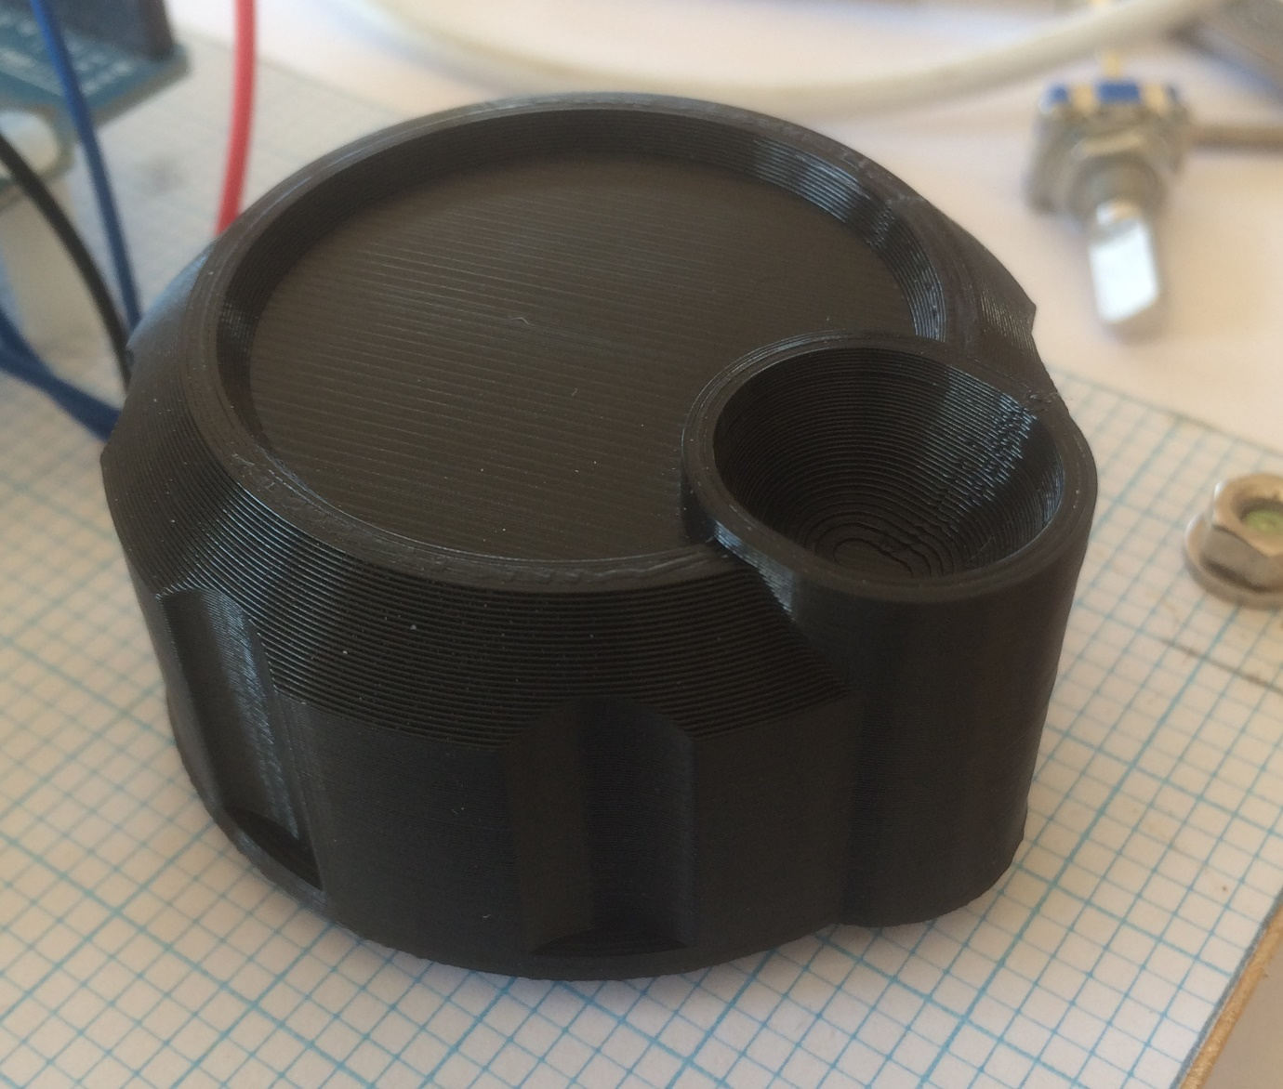

Fig 1

It has a small hole on the side, and a small nut and bolt can be used as grub screw to secure the knob to a rotary encoder shaft. It worked well; it did what it needed to do but there was something missing. It needed weight, it needed to have momentum. The back of the knob was hollow, and I resolved the momentum issue by adding lead weights. Being a bit of a hoarder – how small does an offcut of wooden need to be to be useless? – I had in stock some small pleasing lead cylinders that were recycled from an old piano. There was one in every key to act as the key return mechanism. Six of these fitted nicely in the recess. I encased the weights in epoxy resin – See Fig 2. With the edition of the weights, it felt a great deal better, it felt like an FT-707.

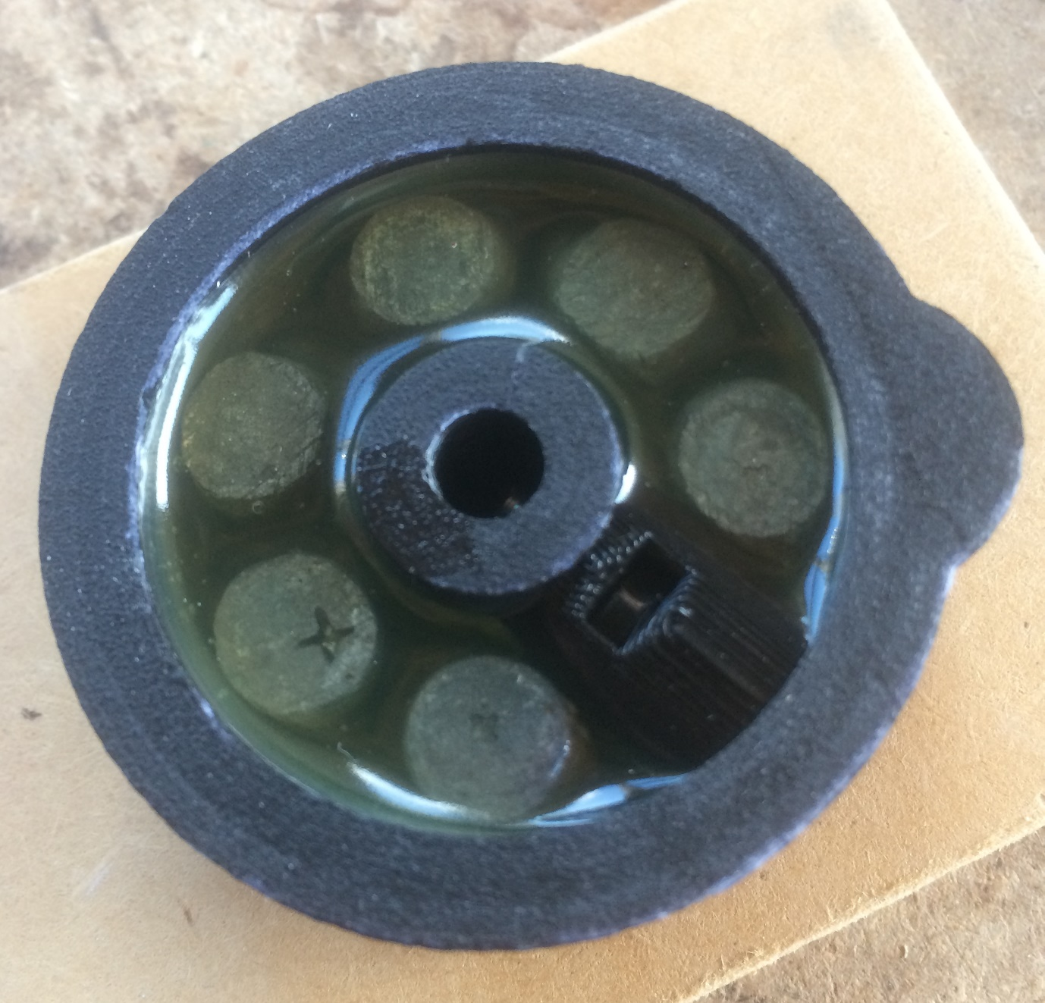

Fig 2

If you wish to print one off then the necessary file can be found at https://github.com/MartinDavidWaller/FT-707-Tuning-Knob. Since publishing the files I’ve noticed that some vendors are selling these on a popular retail site. If you want to try one but don’t have access to a 3d printer then I’d be more than happy to print one off at cost. I don’t want to make any profit from this.

